Lab-6 : The Complete CLI Workflow (File Ingest & Real-time Stream)
Goal: Use the Redpanda command-line tools (rpk and rpk connect) to manage a Redpanda Cloud topic and build a complete data pipeline that first ingests data from a file and then streams it back to your console in real-time.

Purpose of the Lab
This lab provides a comprehensive, end-to-end experience using only Redpanda's command-line tools. It is designed for operators, SREs, and developers who prefer a configuration-driven, no-code approach to data streaming. By completing this lab, you will master the full lifecycle of a simple pipeline: creating cloud resources, securely managing credentials, building a batch ingestion connector, and then building a separate real-time streaming connector to observe the data flow.

Prerequisites
- A Redpanda Cloud account with a running cluster.
- The rpk CLI and rpk connect binary installed on your local machine.

Project Layout
You will create a single directory for this lab which will contain all the necessary files.
rp-cli-cloud-lab/
├── users.jsonl
├── file-to-cloud.yaml
├── cloud-to-stdout.yaml
└── .env

Part 1: Ingesting Data from a File

Step 1: Get Cloud Credentials and Create a User
- Navigate to Security: In the Redpanda Cloud UI, click on the Security tab in the left-hand menu.
- Create a User: Go to the Users sub-tab. Click Create user. Give the user a name (e.g., cli-user) and save the generated username and password in a secure, temporary location.
- Go to ACLs: Click on the ACLs sub-tab.
- Grant Permissions: Click Create ACL. Select the cli-user you just created. For the lab, select the Allow All preset for permissions, then click Create.
- Get Broker Address: Go to the Clusters page, select your cluster. On the Overview page, click the Kafka API tab and copy the Brokers address

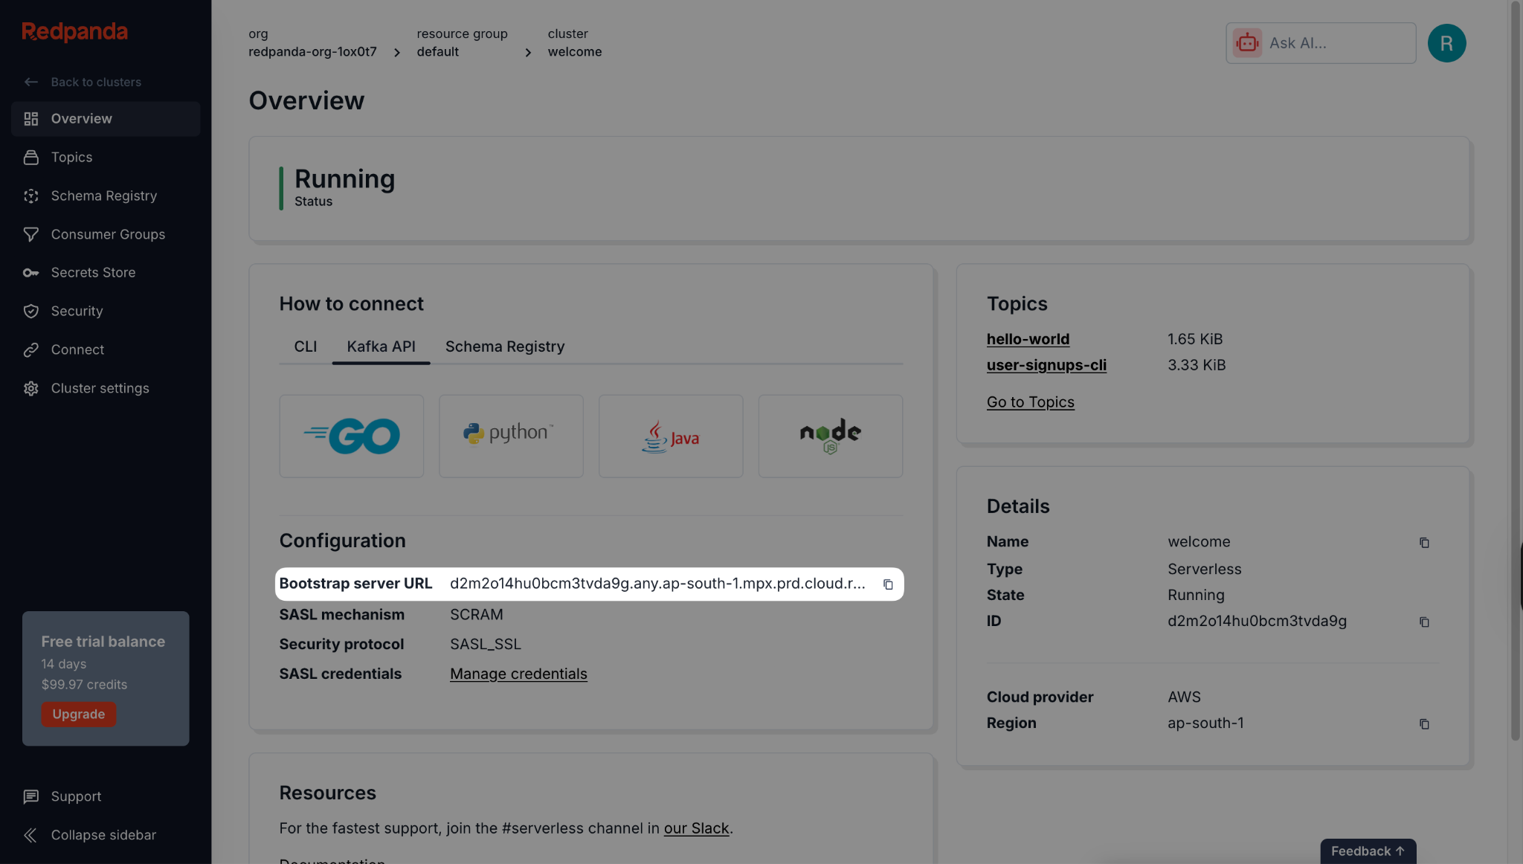

Step 2: Create an rpk Profile
- Log in to Redpanda Cloud:
rpk cloud login
- Create a Profile: This saves your cloud connection details under a memorable name.
rpk profile create --from-cloud
Follow the prompts. A common default profile name is rpk-cloud.

Step 3: Prepare the Project
- Create the project directory:
mkdir rp-cli-cloud-lab
cd rp-cli-cloud-lab

- Create a sample data file named users.jsonl:

users.jsonl
{"id":1,"email":"alice@example.com","country":"USA"}
{"id":2,"email":"bob@example.com","country":"CA"}
{"id":3,"email":"carol@example.com","country":"UK"}

- Create the destination topic on Redpanda Cloud:
rpk topic create user-signups-cli --profile rpk-cloud

- Create the Environment File (.env): This file will securely hold your secrets.
.env
# .env
REDPANDA_BROKERS="<YOUR_BROKERS_URL>"
REDPANDA_USER="<YOUR_USERNAME>"
REDPANDA_PASS="<YOUR_PASSWORD>"
Replace the placeholders with the credentials for the cli-user you created in Step 1.

Step 4: Create the Ingestion Pipeline Configuration
Create a file named file-to-cloud.yaml. This connector will read your local file and send it to the cloud topic.

file-to-cloud.yaml
# file-to-cloud.yaml
input:
file:
paths: ["./users.jsonl"]
codec: "lines"
pipeline:
processors:
- bloblang: 'root = this.merge({"ingest_time": now().string()})'
output:
kafka:
addresses: [ "${REDPANDA_BROKERS}" ]
topic: "user-signups-cli"
tls: { "enabled": true }
sasl:
mechanism: "SCRAM-SHA-256"
user: "${REDPANDA_USER}"
password: "${REDPANDA_PASS}"

Step 5: Run the Ingestion Pipeline
Execute the connector using the --env-file flag to load your credentials.
rpk connect run --env-file .env ./file-to-cloud.yaml

Expected output: The connector will start, connect, process the three records, and shut down.

Step 6: Verify the Ingestion
- Verify with rpk: Use rpk to confirm the data has landed in your cloud topic.
rpk topic consume user-signups-cli -n 3 --profile rpk-cloud
You should see the three user records, now enriched with an ingest_time field.
- Verify in Cloud UI: Navigate to your topic's Messages tab in the Redpanda Cloud UI to see the records.
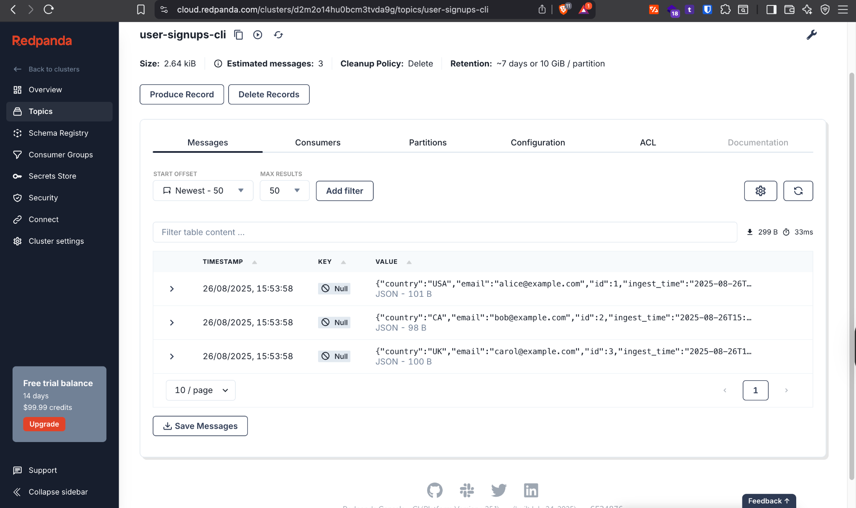

Part 2: Streaming Data in Real-time

Step 7: Create the Streaming Pipeline Configuration
Create a second configuration file named cloud-to-stdout.yaml. This connector will subscribe to your cloud topic and print any messages it receives.

cloud-to-stdout.yaml
# cloud-to-stdout.yaml
input:
kafka:
addresses: [ "${REDPANDA_BROKERS}" ]
topics: [ "user-signups-cli" ]
consumer_group: "cli-stdout-printer"
start_from_oldest: true
tls: { "enabled": true }
sasl:
mechanism: "SCRAM-SHA-256"
user: "${REDPANDA_USER}"
password: "${REDPANDA_PASS}"
output:
stdout:
codec: "lines"

Step 8: Run the Streaming Pipeline
In the same terminal, run the new streaming connector.
rpk connect run --env-file .env ./cloud-to-stdout.yaml

Expected output: The connector will start, print the three existing messages from the topic, and then wait for new messages.

Step 9: Test the Real-time Stream
- Open a new terminal window and navigate to the same project directory.
- Use rpk to produce a new message to your cloud topic.
rpk topic produce user-signups-cli --profile rpk-cloud

- The command will wait for input. Type a new JSON message and press Enter.
{"id":4,"email":"dave@example.com","country":"AU"}

Step 10: Verify the Stream
- Verify in Terminal: Switch back to your first terminal where the streaming connector is running. You should see the new message for "dave" appear almost instantly.
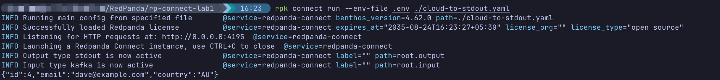
- Verify in Cloud UI: Refresh the Messages tab in the Redpanda Cloud UI. You will now see the fourth record for "dave" at the end of the list.
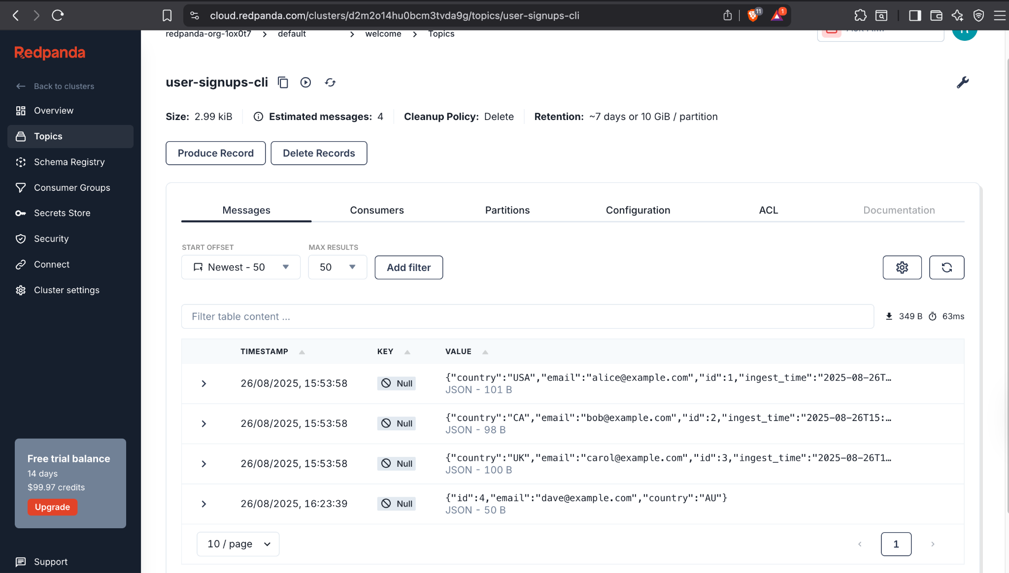

Cleanup
- Stop the streaming connector by pressing Ctrl+C.
- Delete the topic from Redpanda Cloud.
rpk topic delete user-signups-cli --profile rpk-cloud

